AUGUST 2021
VCOSS submission on the Victorian
Gas Substitution Roadmap consultation

VCOSS welcomes the opportunity to provide feedback on the Victorian Government’s consultation paper for the development of a Gas Substitution Roadmap for our State.
VCOSS is the peak body for social and community services in Victoria. VCOSS supports the community services industry, represents the interests and highlights the voices of Victorians experiencing disadvantage and vulnerability in policy debates, and advocates for the development of a sustainable, fair and equitable society.
Victoria’s transition to a more just and clean energy future will require detailed, often technical, deliberation on topics such as infrastructure economics and energy market and technology innovation, including inter-dependencies.
VCOSS’ input at this time is focused on how the roadmap’s priority actions are structured for maximum public benefit.
Whatever decarbonisation pathways the roadmap ultimately proposes, it is critical that it include a clear plan for providing Victorians who need it with financial and practical support throughout this transition.
At the same time, the implications of this transition on low-income households are not just costs and potential policy risks to be mitigated.
Instead, they should be prioritised as investment opportunities for better household wellbeing and State-wide environmental and economic outcomes.

Leverage the Roadmap to connect reform processes
The current roadmap development process was funded in the Victorian Government’s 2021-22 State Budget and is intended to ultimately detail the actions the Government will take to achieve the substantial carbon emissions necessary in Victoria’s gas sector to meet the State’s climate change targets.
As outlined in the consultation paper, the proposed roadmap will include detailed counter-factual analysis and scenario planning across different “decarbonisation pathways”.
These include:
- Improving energy efficiency
- Electrification of household heating and cooking appliances
- renewable gas substitutes (biogas, biomethane and hydrogen), and
- Other emerging technologies and gas sector emission reduction options.
Of course, Victoria’s policy deliberation on these issues – and the roadmap’s investigation of key facts and potential scenarios – isn’t happening in a vacuum.
Other important policy and regulatory activity in this area includes the Australian Energy Regulator’s rolling work in determining how much the monopoly gas distribution networks are paid (which flows through to households’ bills). In Victoria, modelling on the “future of gas” is also one part of the engagement activities already being run by the Victorian distribution businesses.
As the roadmap is developed, it is important that policy makers continue to ‘join the dots’ between these different pieces of work.
This will enable both a shared set of key facts and, more importantly, a deeper public understanding of the urgency, implications and feasibility of a net-zero transition.

Laying some markers in
a dynamic landscape
VCOSS welcomes the Government’s systematic and transparent approach to tackling this complex policy problem.
For some energy system observers, a rapid (and well-managed) electrification of our energy needs is a “no-brainer”. Others – including the gas distribution businesses – emphasise the potential risks of closing off future choices and “renewable gas” technologies.
From a practical perspective, VCOSS recognises that some balanced combination of all pathways is likely to be required. To be clear, however, efficiency and electrification will almost certainly have to “do the heavy lifting” at a household level – which is why this submission is focused on how they will affect Victorians living in low-income and/or disadvantaged circumstances.

Putting people first
Climate change demands an urgent, comprehensive and coordinated response – but that response must also be fair and equitable. This is because the household and public costs of not addressing energy affordability and climate change together have immediate and compounding negative impacts on those Victorians who are already in vulnerable circumstances.
This VCOSS position was outlined in our 2019 report, A Climate of Fairness, and further reinforced by our recent 2021 report on extreme heat. A key message to policy makers is that placing the people and communities who are most vulnerable to climate change at the centre of decision-making and planning is critical to any equitable response.
At a household-level, and as the Roadmap consultation paper recognises, the current (and projected) contribution of natural (fossil fuel) gas in meeting the energy needs of Victorian households is significant and seasonal, with:
- 83% of Victorian households connected to mains gas; and
- 74% of residential gas use per household (on average) being used on space heating in winter.
As the roadmap is developed and the potential impact of different substitution pathways is explored, it will be important that the roadmap include more detailed demographic breakdowns on affected households.
One current (though limited) State-wide data point is the take-up of the Winter Gas Concession. That concession entitles Victorians who receive certain Commonwealth Government income support payments to 17.5% off their total retail gas bill between May and October.
The latest 2021-22 State budget data suggests 679,823 low-income Victorian households will access that concession in 2021-22, although that figure does not capture other ineligible households that are nonetheless experiencing disadvantage and which are dependent on gas for heating (and/or potentially under consuming energy to afford other necessities).
Finally, another important equity dimension for the Victorian Government to consider in the roadmap – and establish shared facts on – is how the potential gas substitution scenarios play out across the State, including in terms of regional equity.

Apply lessons from recent programs
Creating a policy framework for a more just and clean energy future is not easy, particularly when we recognise the potential worst-case future scenario of dual-fuel
low-income households bearing the residual costs of a declining gas distribution network.
VCOSS has previously advocated for a more managed approach to energy transitions, both at the level of supporting individual communities affected by the retirement of coal-fired power stations and through cross-sector leadership.
The current roadmap development process provides a sound basis for the State to consider policy options and make the right public policy choices for a more just and clean energy future. VCOSS is pleased to see (through Key Issue 6) that the Government is engaging with the potential financial risks for low-income and vulnerable households.
On the specific question of how households can best be supported, and the costs of transition be borne equitably, VCOSS makes two observations.
Firstly, while Victoria’s current reliance on natural gas for residential energy needs is substantial, we are not starting the journey to net zero from scratch.
Across the full range of policy levers – from household energy literacy, advice, efficiency and upgrades, through to minimum building and rental standards – the roadmap can leverage lessons learned from previously-funded programs (such as, for example, Energy Savvy Upgrades).
Perhaps the key lesson here is that major appliance upgrades in low-income and/or vulnerable households will ultimately require both some combination of grants and no-interest loans, and trusted frontline community supports to help people navigate and access these upgrades.
Secondly, and as anticipated by the Government’s own current Home Heating and Cooling Upgrades program, the costs of supporting households with energy efficiency and appliance upgrades can actually deliver multiple public benefits (through healthier and more affordable home heating, job creation, and reduced emissions).

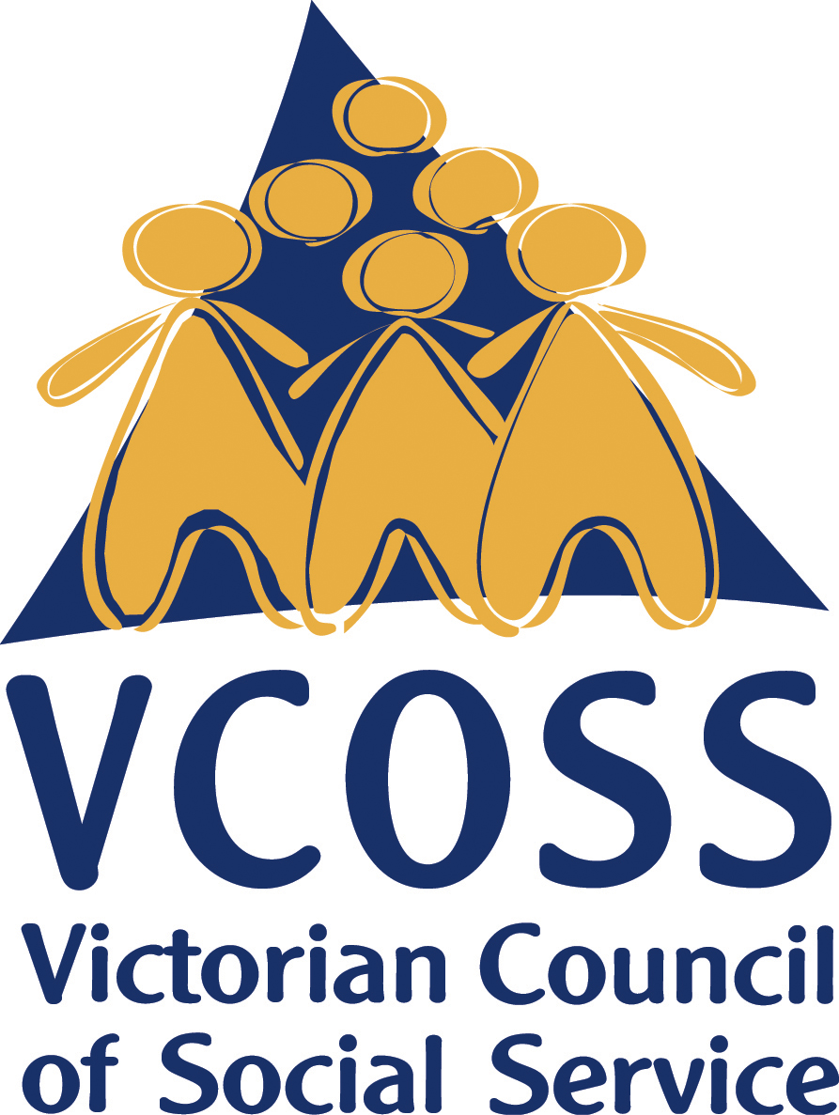

/vcoss
@vcoss
ChannelVCOSS
vcoss.org.au

By explicitly recognising these multiple public benefits, the Victorian Government can incorporate in the roadmap both the technical variables and policy choices that will help clearly define the State’s pathway to a more just and clean energy future.

To discuss this submission, please contact Jarrod Lenne, Energy Policy Advisor on jarrod.lenne@vcoss.org.au

